CSE project

Name: Progga Labani Howlader Roll: 1509035 Dept: ECE

Course no: CSE-3100 Year: 3rd Semister: 1st

Heading: Book Store.

Goal: People can search any types of books & order it quickly.

Description: After signup or login people will enter my website home page. In the top of left side a bookstore logo is presented. At this page in the left side book store history is presented. People can see it by clicking up & remove it by clicking down. In the middle the book store related sliding content present. At the right side people can see the feature books.

In my website many pages are visited by the users. Such as home page, subject page, writer page, Book page, most sell out book page, discount book , children book, book order page, contact page.

In the subject page , people can see different subject books. Pressing any kind of subject, they can find different writers. By clicking any writer user can see many books of this writer. People can see also a search box. They can search the book name or the 1st letter of the book and then the book name &price are shown in the display.

At the writer page people can search the 1st word of the writer name & will find the book name of this writer in the display.

In the book page many feature books are displayed. By clicking any book name they will see this book details. If this book is required, they would have ordered it instantly.

In the order page user can order their necessary books by filling the order form. If they fill it correctly, their order will successful &they will get their books at quickly.

At the contact page users can contact admin by using phone or sending email .

I also make the admin page. After logging the admin can enter this page. Subject admin, Book admin, Most sell book admin, Discount book admin, Children book admin, Contact page admin, view order page include in this admin panel.

In the subject admin page , admin can insert & delete any subject according to her wish.

In the book admin page, admin can add book details with image, edit or delete book.

In the contact page admin can add or delete any admin. If the email address is wrong, the new admin will not add & invalid email is printed in the display.

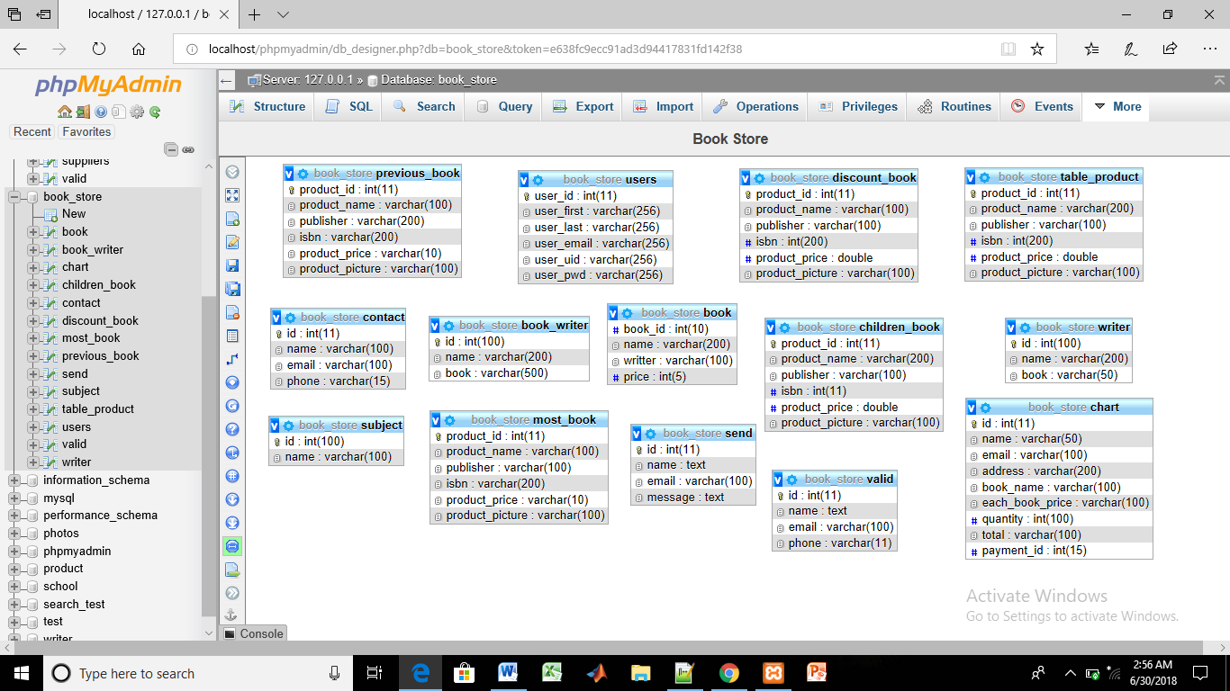

Figure: Design of the table

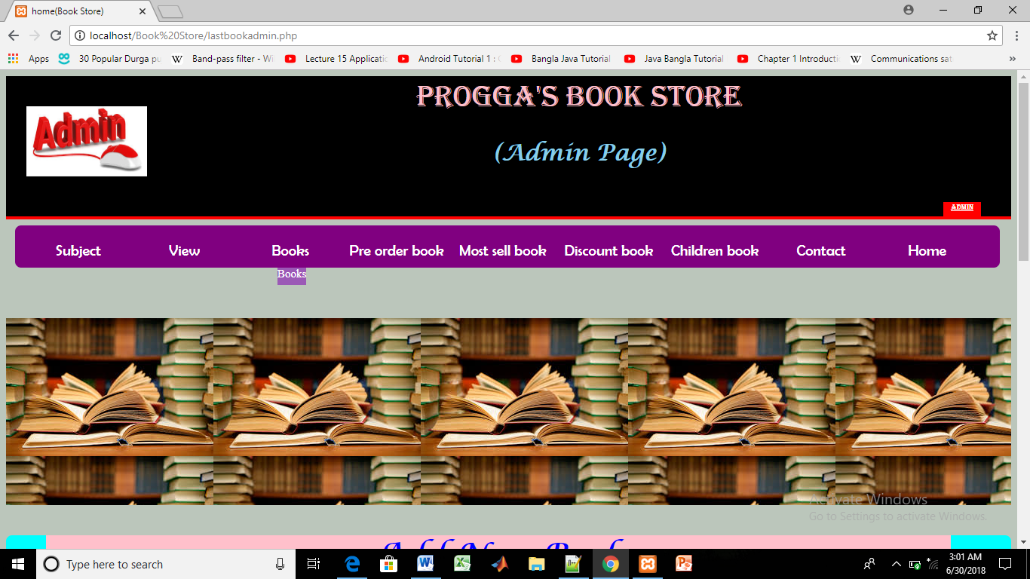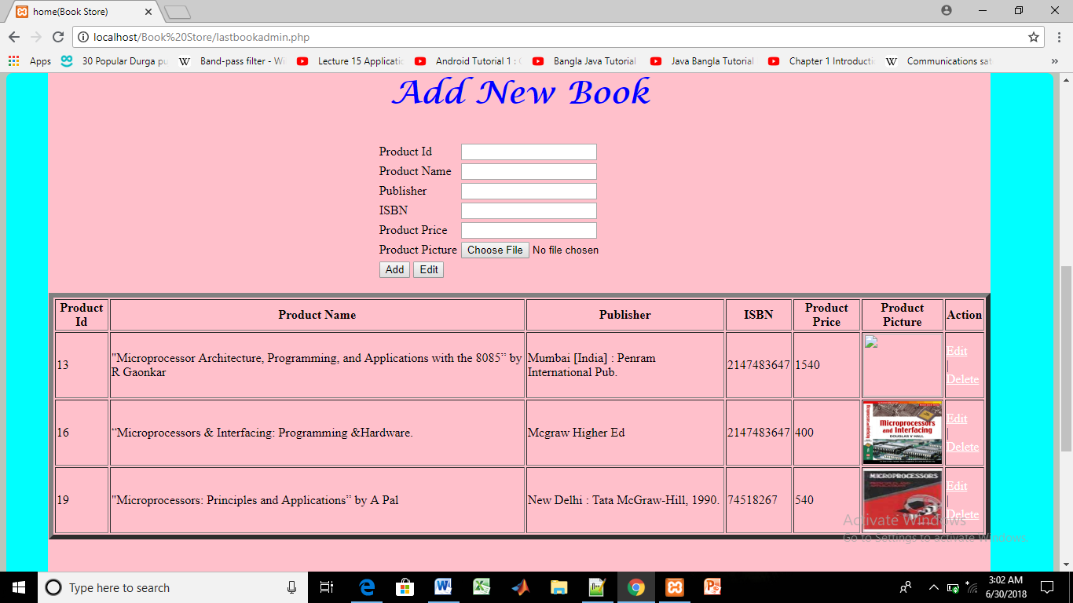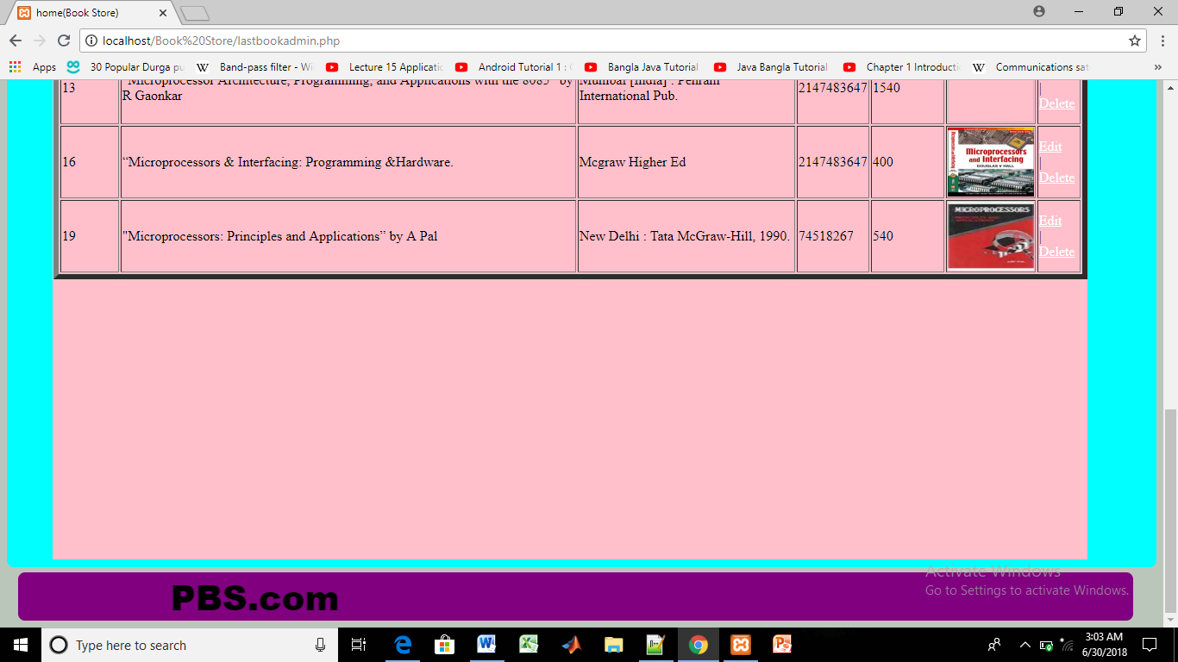

Figure: Admin page

Home page:

Before clicking book store history:

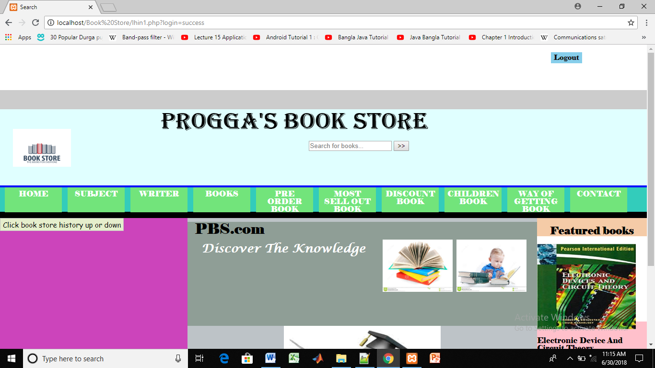

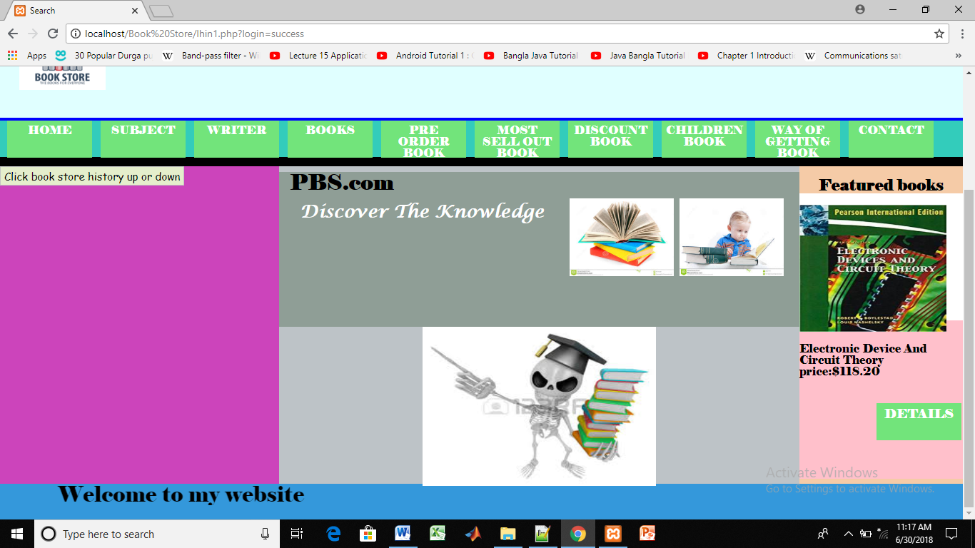

After clicking book store history:



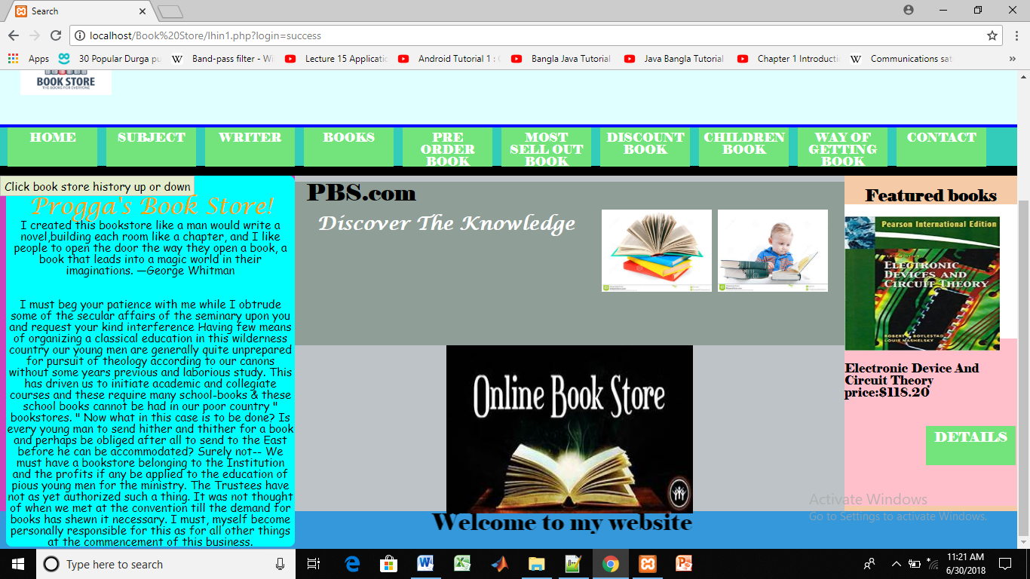

Thinking more works:

1. I had desire to make a payment method.

1. I had desire to ensure how many books are presented at the same type in this book store.

3. Admin logout page.

4. Counting total taka automatically by giving per book price & no of books.

Future goal:

1. In the future people will read books in the online.
2. After doing order people will get their required books at a few time.
3. Admin will make a grail print for blind people so that they can read book by touching page.

End